Cybersecurity Analyst Internship
Task Report

[samfelix15@gmail.com]
Task No: [8 - Cryptography Basics]

Copyright © 2024 EncryptEdge Labs. All rights reserved
Credit: Offensive Security

Table of Contents
1.0 EncryptEdge Labs Internship Task Report 2
1.1 Introduction 2
1.2 Objective 3
1.3 Requirements 4
2.0 High-Level Summary 13
2.1 Recommendations 13
2.2 Risk exposure over time 15
3.0 Report - Methodologies 15
3.1 Information Gathering 15
4.0 Additionals Item 16
1.0 EncryptEdge Labs Internship Task Report
1.1 Introduction
Cryptography is the practice and study of techniques for secure communication in the presence of third-party adversaries. It involves the use of algorithms and protocols to protect the confidentiality, integrity, and authenticity of messages. Cryptography is a crucial component of cybersecurity, as it enables organizations to safeguard their sensitive data and communications.
Cryptography is a combination of mathematics, computer science, and engineering that focuses on designing and analyzing algorithms for secure data transmission. It involves the use of cryptographic primitives, such as encryption algorithms, hash functions, and digital signatures, to protect data against unauthorized access, tampering, and eavesdropping.
The primary goals of cryptography are to ensure the confidentiality, integrity, and authenticity of data. Confidentiality protects data from unauthorized access, while integrity ensures that data is not tampered with or altered during transmission. Authenticity verifies the identity of the sender and the integrity of the message. Non-repudiation ensures that the sender cannot deny sending the message.
Cryptography has numerous real-world applications. It is used to protect sensitive data, such as credit card numbers and passwords, during online transactions. It is also used to protect emails, instant messages, and other forms of communication. Additionally, cryptography is used to protect sensitive data, such as financial information and personal identifiable information, and to protect copyrighted content, such as music and movies.
In this report we will explore the different types of cryptography algorithms and their impact in cybersecurity.

1.2 Objective
Build a foundational understanding of encryption by covering key concepts and algorithms
Give insight in how encryption is applied in real world cybersecurity scenarios
Practical knowledge on how to use encryption tools to encrypt and decrypt files, message
1.3 Requirements
The purpose of this report is to provide a comprehensive introduction to cryptography and its related aspects, we will highlight in depth the basic syntax, common tools and best practices for getting started with cryptography
Key Objective
1. Define the basic syntax of cryptography
2. Identify the various types of cryptography, examples of each types, and how they aid or contribute in the world of cybersecurity.
3.Gain hands on experience on how to navigate through the various cryptography tools and which approach is suitable depending of the case of study.
Deliverables:
- Submit a summary comparing symmetric and asymmetric encryption using examples to illustrate the difference and explaining each concept in cybersecurity.
- Submit a report that discusses real world encryption application with specific examples such as emails or file storage encryption and their role in cybersecurity.
- Provide screenshots of the encryption and decryption process, along with the step by step guide and explanation of the command used
Tools Used: In this report, cryptographic tools used include Open SSL,GPG (GNU Privacy Guard) and Online Encryption Simulation Platforms

Types of Cryptography:
Symmetric cryptography
Uses the same secret key for both encryption and decryption. Here are some common types of symmetric cryptography:
1. Block Ciphers: Divide plaintext into fixed-length blocks and encrypt each block independently. Examples include AES (Advanced Encryption Standard), DES (Data Encryption Standard), and Blowfish.
2. Stream Ciphers: Encrypt plaintext one bit or byte at a time. Examples include RC4 (Rivest Cipher 4) and FISH (Fast and Secure Hash).
3. Hash Functions: One-way functions that take input data of any size and produce a fixed-size output. Examples include SHA-256 (Secure Hash Algorithm 256) and MD5 (Message-Digest Algorithm 5).
Example:
Suppose Alice and Bob share a secret key. Alice encrypts a message using the shared key and sends it to Bob. Bob decrypts the message using the same shared key.
Asymmetric Cryptography
Asymmetric encryption, also known as public-key encryption, uses a pair of keys: a public key for encryption and a private key for decryption. The public key is shared openly, while the private key is kept secret. Asymmetric encryption is commonly used for secure communication over the internet, such as SSL/TLS. Common types of asymmetric cryptography includes
1. RSA (Rivest-Shamir-Adleman): A widely used public-key encryption algorithm that uses the product of two large prime numbers to create the public and private keys.
2. Elliptic Curve Cryptography (ECC): A type of public-key cryptography that uses the mathematical properties of elliptic curves to create the public and private keys.
3. Diffie-Hellman Key Exchange: A key exchange algorithm that allows two parties to establish a shared secret key without actually exchanging the key.
4. Digital Signatures: A type of asymmetric cryptography that uses a hash function and a private key to create a digital signature, which can be verified using the corresponding public key.
Example:
Suppose Alice wants to send a secure message to Bob. Alice encrypts the message using Bob's public key, which is freely available. Bob then decrypts the message using his private key, which is kept secret.
Hybrid Cryptography:
Hybrid cryptography combines the benefits of symmetric and asymmetric cryptography. It uses asymmetric cryptography to establish a shared secret key, which is then used for symmetric encryption.
1. SSL/TLS (Secure Sockets Layer/Transport Layer Security): A hybrid cryptography protocol that uses asymmetric cryptography to establish a shared secret key, which is then used for symmetric encryption to secure web traffic.
2. PGP (Pretty Good Privacy): A hybrid cryptography protocol that uses asymmetric cryptography to establish a shared secret key, which is then used for symmetric encryption to secure email communications.

Major Key Differences Between Symmetric and Asymmetric Cryptography:
Symmetric and asymmetric cryptography are two fundamental approaches to encryption, each with its own strengths and weaknesses. Understanding the differences between these two approaches is crucial for selecting the most appropriate encryption method for a given use case.
1. Key Usage:
Symmetric Cryptography: Uses the same secret key for both encryption and decryption.
Asymmetric Cryptography: Uses a pair of keys: a public key for encryption and a private key for decryption.
2. Key Exchange:
Symmetric Cryptography: Requires a secure key exchange mechanism to share the secret key between parties.
Asymmetric Cryptography : Eliminates the need for a secure key exchange mechanism, as the public key can be freely shared.
3. Encryption Speed:
Symmetric Cryptography: Generally faster and more efficient than asymmetric cryptography.
Asymmetric Cryptography: Slower and more computationally intensive than symmetric cryptography.
4. Security:
Symmetric Cryptography Secure as long as the secret key remains confidential. Asymmetric Cryptography : More secure due to the use of separate keys, making it more difficult for an attacker to obtain the private key.
5. Scalability:
Symmetric Cryptography: More scalable than asymmetric cryptography, as it can handle large volumes of data more efficiently.
Asymmetric Cryptography: Less scalable than symmetric cryptography, due to its slower encryption speed and higher computational requirements.
6. Key Management:
Symmetric Cryptography : Requires secure key management to protect the secret key.
Asymmetric Cryptography: Requires secure key management to protect the private key, but the public key can be freely shared.
7. Authentication:
Symmetric Cryptography: Can provide authentication through the use of message authentication codes (MACs).
Asymmetric Cryptography: Can provide authentication through the use of digital signatures.
8. Key Size:
Symmetric Cryptography: Typically uses smaller key sizes (e.g., 128-bit or 256-bit AES).
Asymmetric Cryptography: Typically uses larger key sizes (e.g., 2048-bit or 4096-bit RSA).
9. Computational Requirements:
Symmetric Cryptography: Requires less computational power than asymmetric cryptography.
Asymmetric Cryptography: Requires more computational power than symmetric cryptography, due to the complexity of the mathematical algorithms used.
10. Real-World Applications:
Symmetric Cryptography: Commonly used for bulk data encryption, such as SSL/TLS and IPsec.
Asymmetric Cryptography: Commonly used for key exchange, digital signatures, and authentication, such as SSL/TLS and PGP.
In conclusion, symmetric and asymmetric cryptography have different strengths and weaknesses, making them suitable for different use cases. Symmetric cryptography is faster and more efficient, but requires secure key management and exchange. Asymmetric cryptography is more secure and eliminates the need for secure key exchange, but is slower and more computationally intensive.

Real-world encryption applications play a vital role in protecting sensitive information and ensuring cybersecurity. Here are some specific examples:
File Storage Encryption
File storage encryption protects data stored on devices such as hard drives, smartphones, and cloud storage services. This type of encryption ensures that even if an unauthorized party gains access to the device or storage service, they won't be able to decrypt the sensitive data without the encryption key ¹. For instance, Apple's FileVault and Microsoft's BitLocker provide full-disk encryption to protect data on laptops and desktops.
Email Encryption
Email encryption protects the confidentiality and integrity of email communications. It ensures that only the intended recipient can read the email content, and any tampering with the email can be detected. Popular email encryption services include ProtonMail and Tutanota, which offer end-to-end encryption for email communications ².
Secure Communication
Encryption is also used to provide secure communication over the internet. Transport Layer Security (TLS) and its predecessor, Secure Sockets Layer (SSL), use cryptographic protocols to establish protected connections between web browsers and servers. This secure channel ensures that data shared between a user's browser and a website remains private and cannot be intercepted by malicious actors [1).
Data Integrity
Cryptography is used to ensure the integrity of data through hash functions. Hash functions generate fixed-size hashes (or digests) of data, which can be used to verify data integrity. Any changes to the data will result in a different hash value, making it detectable ².
Authentication
Digital signatures are used to authenticate the originator or sender of information. Asymmetric cryptography is used to create and verify digital signatures, which can only be generated with the use of a private key. Recipients can use the sender's public key to verify the signature's authenticity and confirm that the document has not been tampered with during transmission ¹.
In conclusion, encryption plays a vital role in protecting sensitive information and ensuring cybersecurity. Real-world encryption applications, such as file storage encryption, email encryption, secure communication, data integrity, and authentication, are essential in safeguarding against unauthorized access, tampering, and eavesdropping.

2.0 High-Level Summary
Cryptography is a crucial component of cybersecurity that enables organizations to safeguard their sensitive data and communications. Understanding the basics of cryptography, including its goals, techniques, and applications, is essential for implementing effective cryptographic solutions. By using cryptographic techniques, such as encryption, digital signatures, and hash functions, organizations can protect their sensitive data and communications from unauthorized access, tampering, and eavesdropping.
Cryptography is a constantly evolving field, with new techniques and algorithms being developed to address emerging threats and challenges. As technology continues to advance, the importance of cryptography will only continue to grow. Therefore, it is essential for individuals and organizations to stay informed about the latest developments in cryptography and to implement effective cryptographic solutions to protect their sensitive data and communications. ‎

2.1 Recommendations
1. Use Asymmetric Encryption for Secure Communication: Employ asymmetric encryption for secure communication over the internet, such as SSL/TLS.
2. Use Symmetric Encryption for Data Storage: Utilize symmetric encryption for secure data storage and transmission within organizations.
3. Implement Secure Key Exchange Mechanisms: Ensure secure key exchange mechanisms are in place for symmetric encryption.
4. Regularly Update and Patch Encryption Protocols: Keep encryption protocols and software up-to-date with the latest security patches and updates.

2.2 Risk Exposure over Time
The risk exposure of encryption methods can change over time due to:
Advances in Computing Power: Increased computing power can compromise encryption methods.
Discovery of Vulnerabilities: Newly discovered vulnerabilities can impact the security of encryption methods.
Emergence of Quantum Computing: Quantum computing poses a potential threat to certain encryption methods.

3.0 Methodologies
This report employed a comparative analysis methodology, examining the characteristics, advantages, and disadvantages of asymmetric and symmetric encryption. The report also considered the role of encryption in cybersecurity, providing recommendations for implementation and risk management.

3.1 Information Gathering
Asymmetric encryption is more secure due to the use of separate keys.
Symmetric encryption is faster and more efficient but requires a secure key exchange mechanism.
Encryption is crucial for data protection, secure communication, and authentication.
Regular updates and patches are essential for maintaining the security of encryption protocols.
Advances in computing power, discovery of vulnerabilities, and emergence of quantum computing can impact the security of encryption methods. ‎
4.0 Additional Items
Below include screenshots of completed encryption and decryption steps using GPG after running kleopatra in the background and also screenshots of completed lab works by TryHackMe.
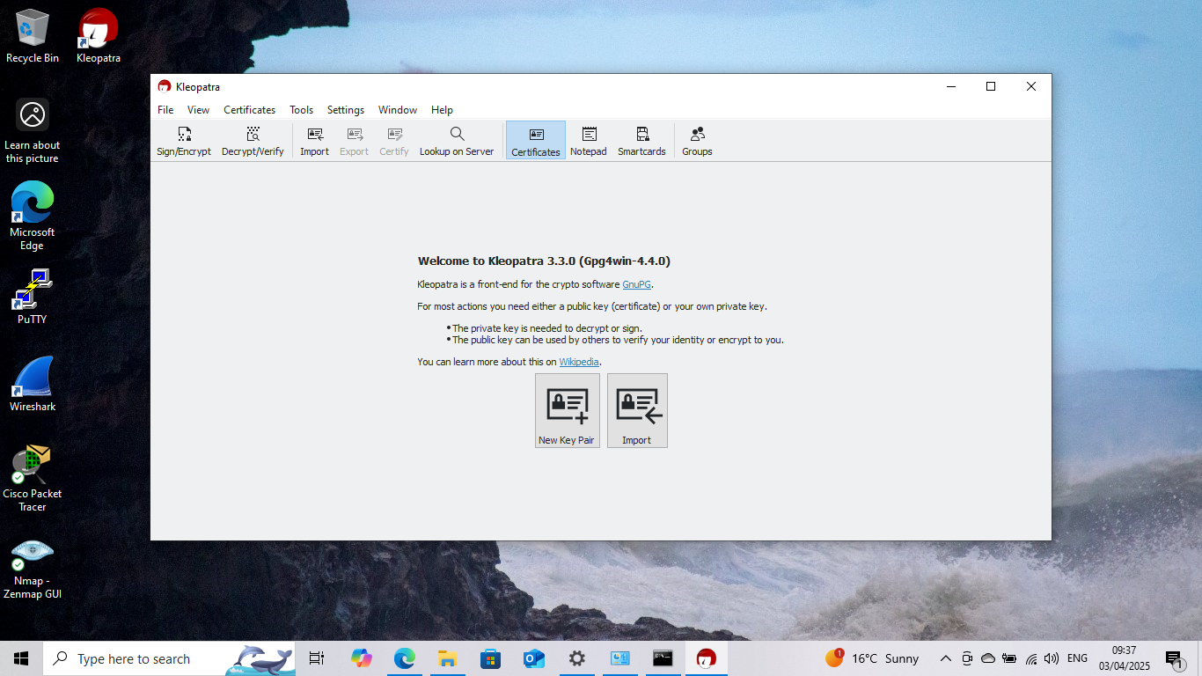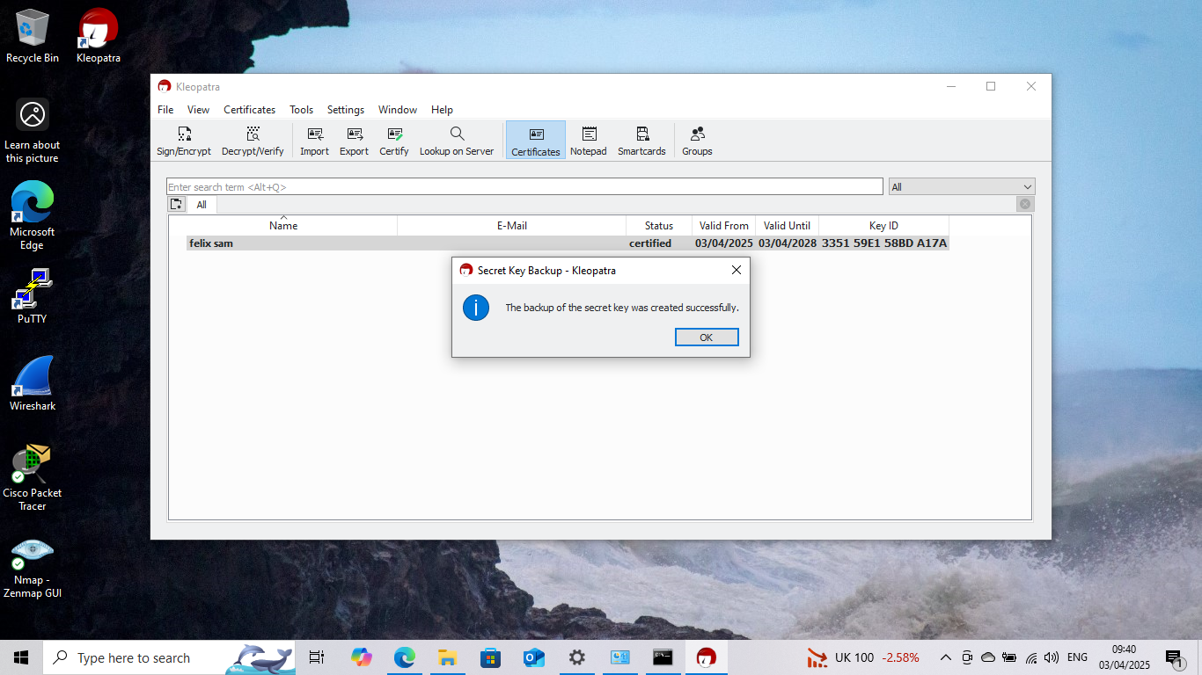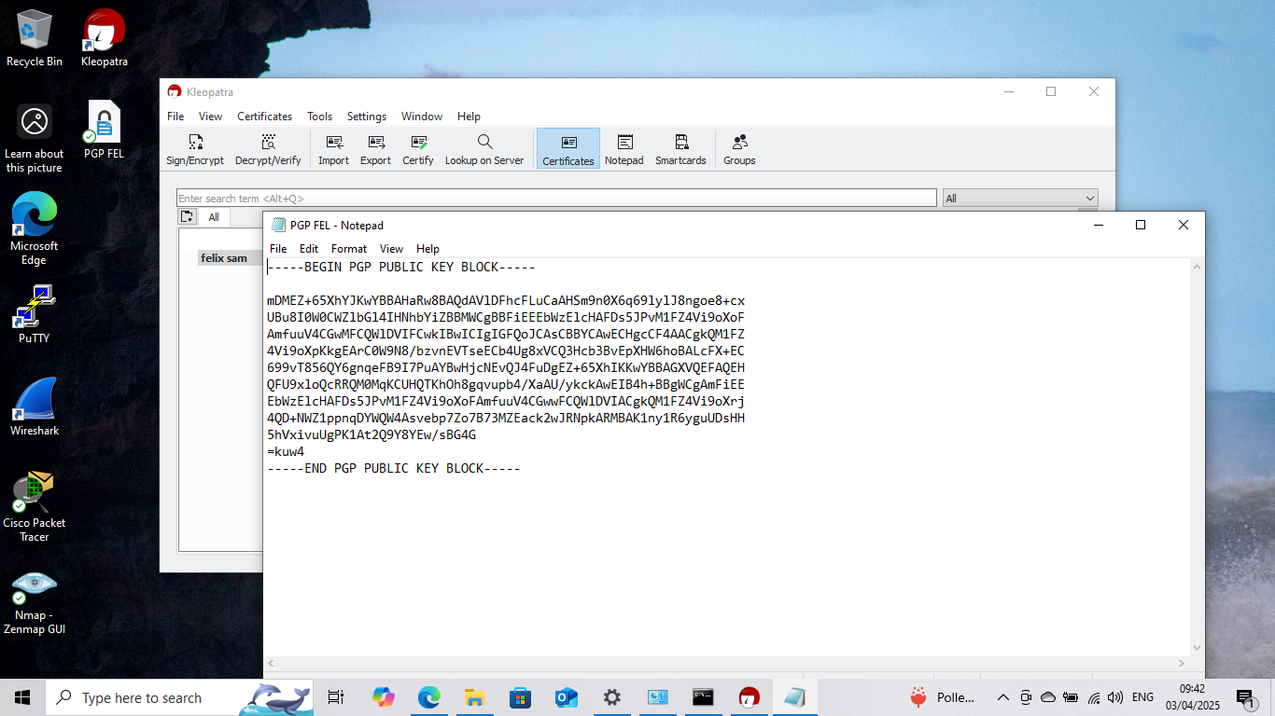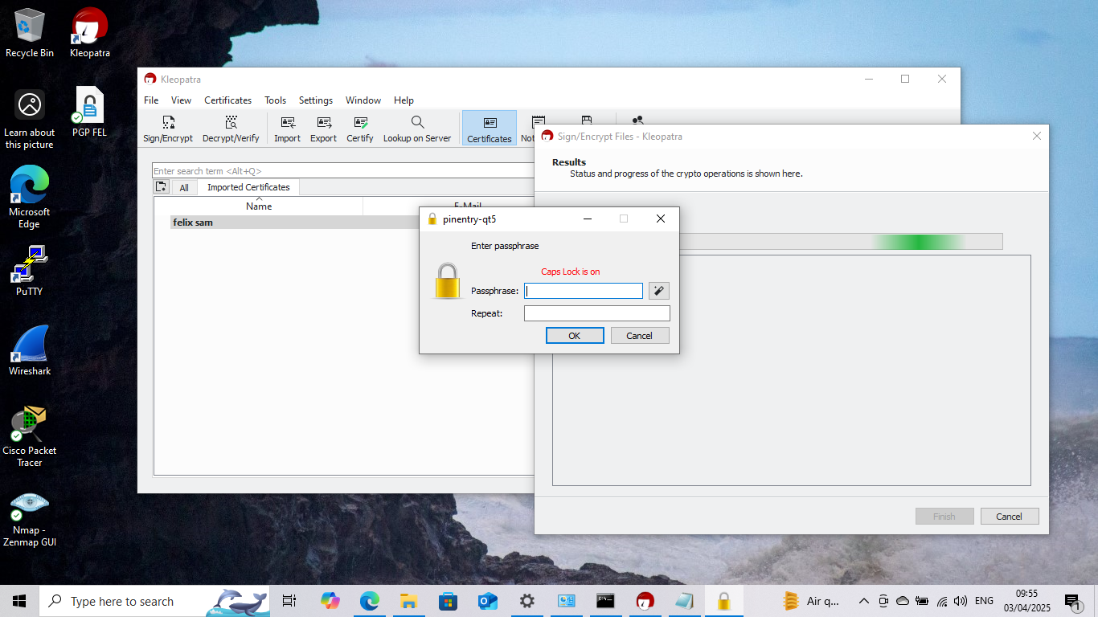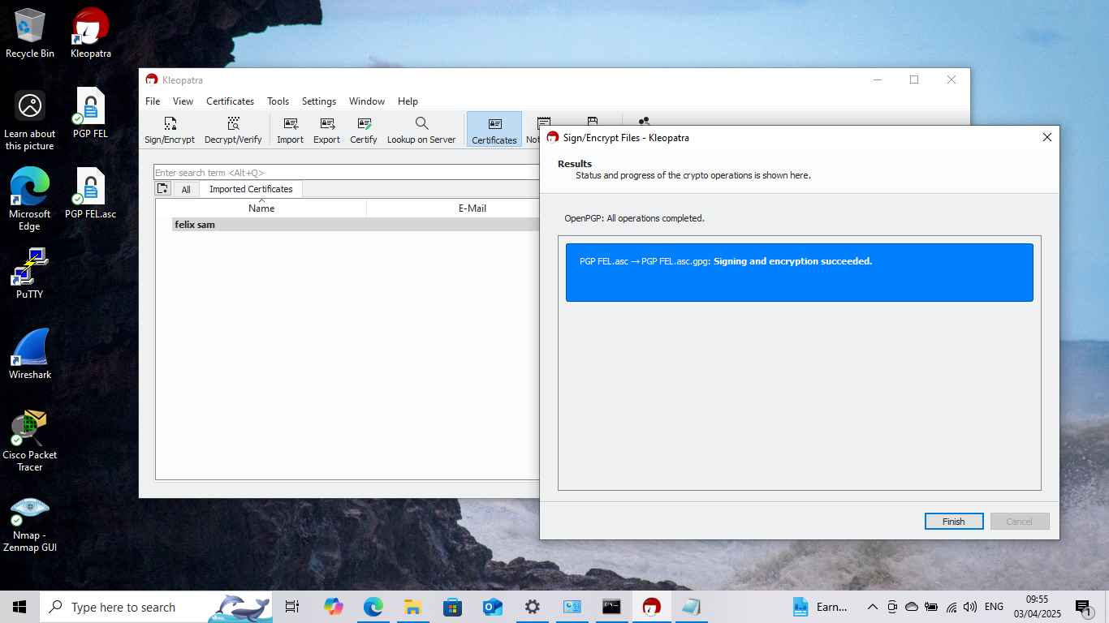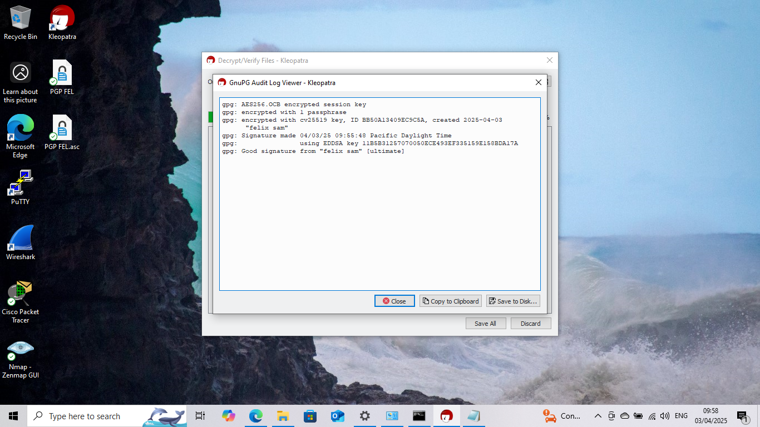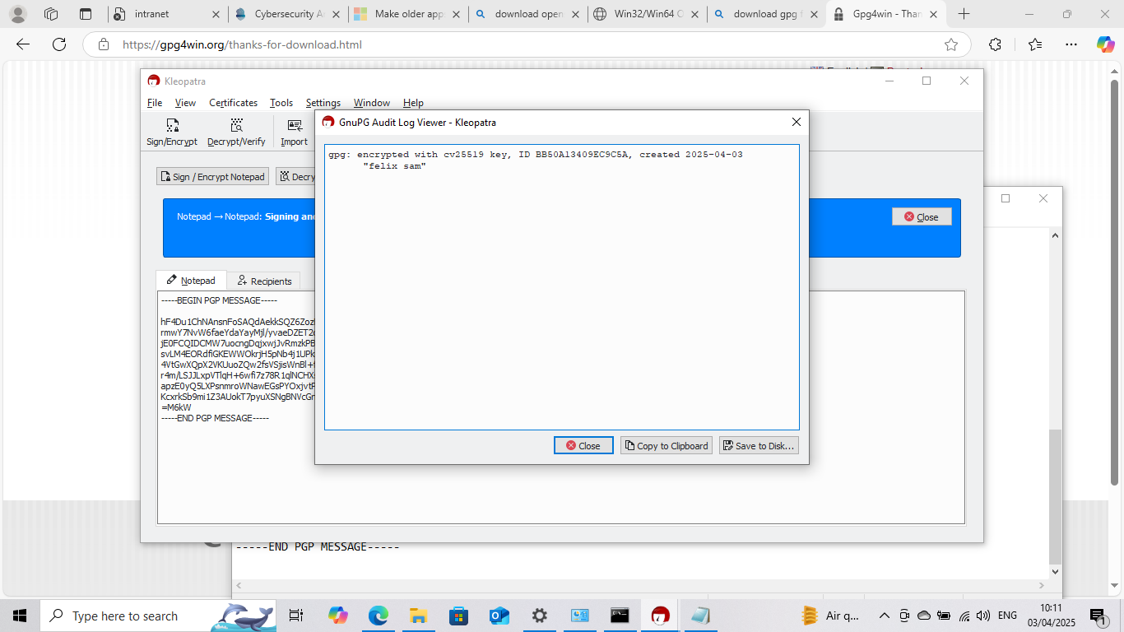

Labs Completion Screenshots(TryHackMe)
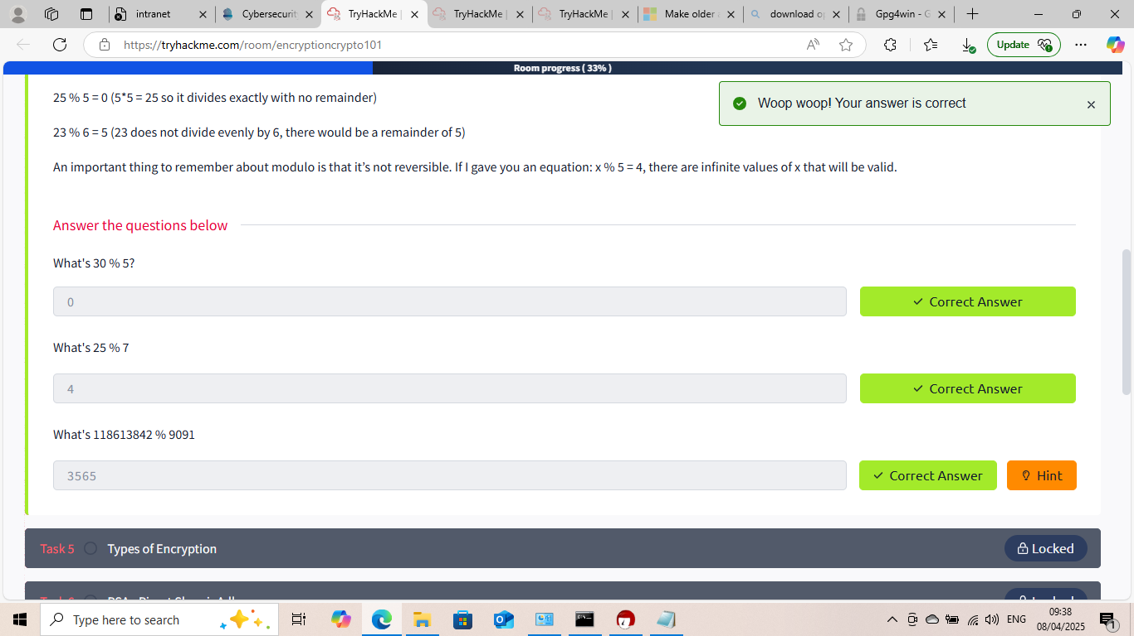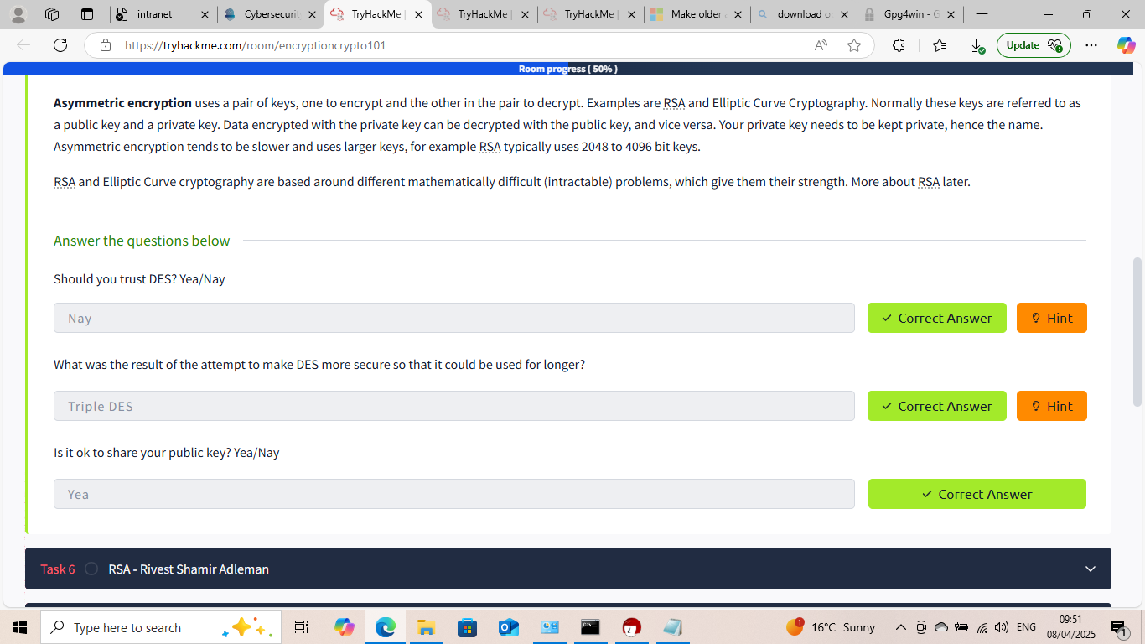


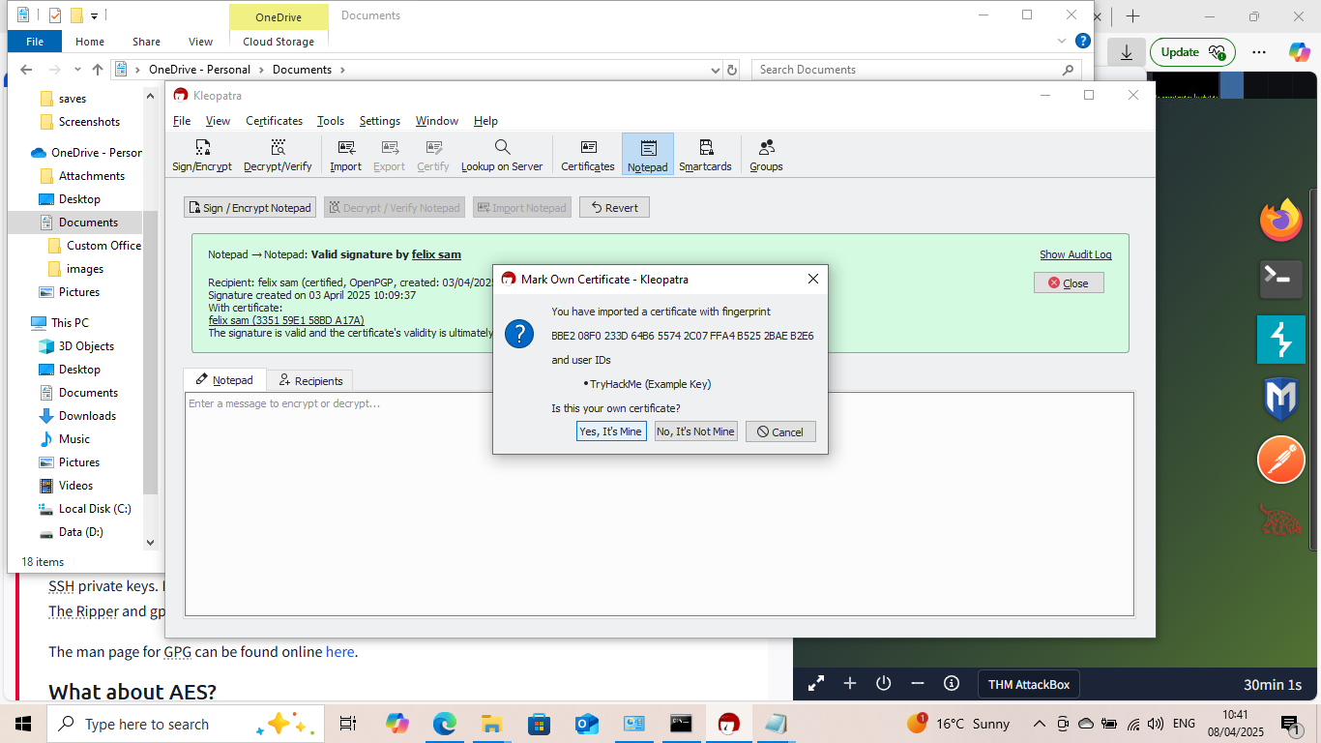
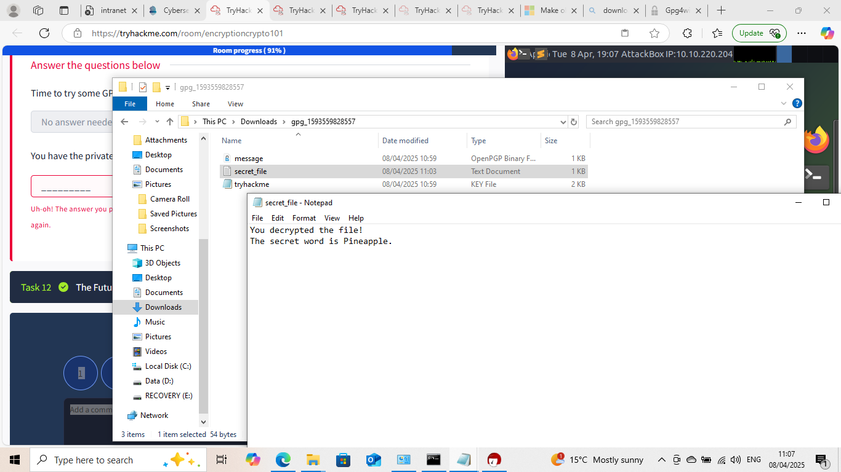





This Internship Task report was developed on [04, 04, 2025]

By:
[samfelix15@gmail.com ]

